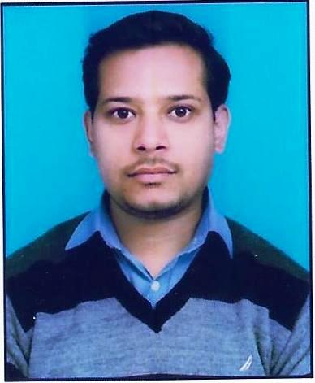
JITENDER RATHORE
Address: H.No-242, Gali No-1, Milk Plant Road,
Kundan Colony, Ballabgarh, Faridabad
Haryana-121004
Mobile No: +919211931745
E Mail: jitenderrathore01@gmail.com

OBJECTIVE

- To seek a Challenging job and develop a successful career.
- Would accept all the challenges through the way, as my Qualifications, Education talent help me to go through things successfully. Will assure that company’s growth and betterment will be a primary factor along with my personal growth.

PROFESSIONAL QUALIFICATION

- I did MBA in Marketing from Sam Higginbottam Inst. Of Agri. Technology & Science. (Allahabad) with approx 75.83% in 2013-2014.
- I did B.com from Vinayaka Missions University. (Tamilnadu) with approx. 62.53% in 2010-2012.

ACADEMIC QUALIFICATION

- Intermediate (Commerce) from Haryana Board of Bhiwani 2005
- High school from Haryana Board of Bhiwani 2003.

TECHNICAL QUALIFICATION

- Six month diploma of Microsoft Word, Microsoft Excel, Power Point, MS Dos, Outlook Express, Mail Merging and Internet etc.

COMPUTER SKILLS

- Application Package : SAP, Word, Excel, Power point, MS Access,
Outlook, Internet,
- Networking known : Local Area Networking (LAN)
- Operating system known : Windows 98, 2000, Window-XP,
Window-7, Window-10
- Internet : Browsing the internet using Microsoft Internet Explorer Web Mail, Web Chat, Using various
Search engines.

STRENGHT

- Self-Management, Decision Making and positive attitude, Punctuality
- Having quick Grasping power & very learning skill.
- Willingness to work hard.

WORK SUMMARY

Present Job

- Working with Hyundai Motor India Ltd (Corporate Office, Sec-29, Gurugram) as a MIS Executive from Jan 2012 to at present.

Job Responsibilities:-

Department: - Institutional Sales

- Operate SAP, Sales & Marketing System, GDMS and Analyzer various software.
- Work on SAP Software for create vouchers, Purchase Order, view budget, watch overall retail of Hyundai Pan India Report.
- Upload GeM Retail Invoice’s on GeM portal and update the car delivery.
- To make Focused models report (Alcazar, I20, Verna and Exter) Region Wise & Dealer Wise daily bases.
- To make Institutional Sales Performance Report daily bases like Corporate, Government, POI, CSD, Taxi & Prime Taxi etc.
- Process Claims in GDMS for Corporate Classic, Corporate Leasing, Bulk, CSD & CPC Sale, Hyundai Associates Scheme etc.
- Analysis of Target Vs. Achievement, Penetration & Penetration Growth Region Wise, Model Wise, Dealer Wise, Report for Dealer as well as for team.
- Make Annual Award Report Dealer wise total Institutional Sales, CSD and Leasing Target Vs. Achievement.
- Coordinate with Regional Managers.
- Using of verity of software packages such as Microsoft Word, PowerPoint Outlook and Excel, SAP….
- V-lookup, H-lookup, Pivot Table, Index Match, If & Nested If. Query, Goal Seek. Conditional Formatting, Concatenate, Sumifs, countifs Data Validation, Text to Column and other various formulas.
- Maintain all Data & Records.

Department: - Service Support

- To fetch report from various internal software’s like Area Management System, Global Dealer Management System, compilation in different formats.
- Make report of daily RO Load region wise with graph.
- Make open vs closed RO data report region wise.
- Reporting of customer delight programmers Courtesy, Emergency road service programmer, Road Side Assistance & Quick Service Program.
- Compilation of MIS Report related to service activities.
- Make Quick Service Report Daily.
- Make Courtesy Car Report Weekly.
- Operate the outlook express and mailing activities.
- Use in excel Pivot Table, V-lookup, Filter and various other formulas.
- Coordinate to APSM(Area Parts Service Managers), Dealers & RPSM
(Region Parts Service Managers).
- Revise target of Courtesy Car.
- Revise Mechanical & Body Paint Labor Rates.
- Letter drafting, mail merging.
- Courtesy Car approved & return.
- Mapping of Hyundai Dealer Service Network.
- Making Daily Ro load Report All India & Region Wise.

Previous Job

- Around 2 years’ experience with M/S Alhind Metal Industries (Faridabad)
As an Accountant assistant.

Job Responsibilities

- Sales, Purchase & other expenses entries in tally 7.2.
- Maintain the attendance register.
- Making the vouchers & entry in tally.
- Operate the Invoice software and dispatch the invoices.
- Making the challan of job work.

PERSONAL VITAE

Name : Jitender Rathore

Father Name : Mr. Basant Rathore

DOB : 25th Sep 1987

Address : H.No-242, Gali No-1, Milk Plant Road,
Kundan Colony, Ballabgarh, Faridabad
Haryana-121004

Languages known : English, Hindi

Marital status : Married

Date:

(Jitender Rathore)

