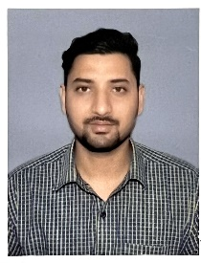
Resume
Nihal Kumar Singh
Address : Saristabad Rajputana Gardanibagh, Patna- 800002
Mobile no. : 7004798878
E Mail : nihalkaushik083@gmail.comcom

CARRER OBJECTIVE
A challenging career which offers an opportunity to apply my skills knowledge with continuous learning and growth
EDUCATION QUALIFICATION
Serial No | degree | Year | Boad | PERCENTAGE
1 | 10th | 2011 | CBSE | 72.2
2 | 12th | 2013 | BSEB | 53.8
3 | BBA | 2016 | AKU | 67.45

TECHNICAL SKILLS
MS WORD, EXCEL, Pivot, Database function, Advance formula, VLOOKUP, Match, Index, Power query etc.
EXPERIANCE
Rivaa Enterprises, Patna 24/01/2024 – 10/03/2025
Analyst
*Closely involve in data management, data processing, data validation, data analyst and reporting.
*Excellent understanding of data management concepts, workflows and execution across any given business problems.
*Analysed data related business problems and provided solutions with Ms Excel technology at hand.
*Preformed basic and hoc analysis to business decisions.
PERSONAL DETAILS
Fathers Name : Narendra Kumar Singh
Date of Birth : 05-09-1996
Marital status : Single
Gender : Male
Religion : Hindu
Nationality : Indian
Language : Hindi, English
DECLLERATION
I hear by declare that the information provided above is true to the best of my knowledge.
DATE…………
PLACE……….
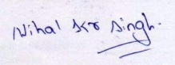
(Nihal Kumar Singh)

